**Software Requirements and Design Document**

**For**

**Group <20>**

Version 2.0

**Authors**:

Nicole Johnson

James Tanner

Michael Carroll

Tyler Carver

Tanner Rohloff

# Overview (5 points)

YUPP is a location-based service application that enables the user to find the best food deals in their area. Our goal is to offer a list of promotional and permanent discounts for the restaurants in a user’s area. We want to give our users the confidence that they are getting the best bang for their buck. YUPP will display restaurants based on distance and price using a map API and allow the user to easily decide where to take their business.

The current state of YUPP includes a near completion of the front-end user interface. We have multiple functioning pages and an application that is visually appealing. We also have placeholder information being used to show how our application will work once completed. The next steps for YUPP are to incorporate true functionality.

# Functional Requirements (10 points)

Where 1 is the highest priority and 6 is the lowest:

1. Communicate with API to retrieve restaurant information.
2. Display the restaurant sale, percentage saved, distance from user, and compare the sale to other, similar sales.
3. When the user enters a cuisine type or restaurant name in the search bar, display restaurants serving food in that category.
4. When the user enters their area code, the map will display restaurants within their area.
5. When the user clicks on an item in the navigation bar, it will take the user to the corresponding page.
6. Once the user enters their login and password, a new account will be created.
7. When the user enters their login information incorrectly, display an error message.

# Non-functional Requirements (10 points)

1. Data Integrity/Reliability: we want the sales to remain current and updated.
2. Availability: this is why we decided on a web app.
3. Security: Individual accounts will have their information protected.
4. Capacity: Ensure images used are not too big in memory to maintain efficiency of webpage loading

# Use Case Diagram (10 points)

Textual descriptions:  
 1.

1. Name: Search restaurants.
2. Description: the user can use the search bar to search for restaurants by name or cuisine type.
3. Participating actor: User, database, map API.
4. Preconditions:

* The user has entered their area code.
* The restaurant API is fully functional.
* There are restaurants fitting that cuisine or name in our database.

5.Postconditions:

- Restaurants successfully display

6.Basic flow of events:

1.User enters their area code.

2.User searches for a restaurant or cuisine using the search bar.

3. Restaurants fitting the search will be displayed.

4.If the user has an account, save searches

7.Alternative Flows:

-There is no restaurant in the user’s area that fits the category that they are searching for.

-àDisplay a ‘no results’ message

- The user searches for a restaurant or cuisine that does not exist.

-àDisplay a ‘no results’ message

-Maps or restaurant API’s stop working.

8.Special Requirements:

-Cuisine, food, and restaurant name are in English.

2.

1. Name: Navigate Pages

2. Description: The user can traverse the website using the navigation bar. Clicking on the name of the page will bring the user to the corresponding page.

3. Participating actor: User.

4. Preconditions:

-Navigation bar is properly set up

-Each page is properly connected to the navigation bar.

5.Postconditions:

-User was brought to the correct page, and the page is fully functional.

6. Basic flow of events:

1. User will click on a category (page) presented by the navigation bar

2. User is brought to the new page

7. Alternative Flows:

-The navigation bar takes the user to a page that does not exist

à Go to a different page.

- The navigation bar brings the user to the correct page, but the page is

incomplete or does not perform the intended purpose.

à Go to a different page.

8. Special Requirements:

-Navigation bar brings you to the correct page every time (reliability).

3.

1. Name: Creating an account

2.Description: The user can create an account to keep track of searches and sales.

3. Participating Actor: User

4. Preconditions:

-The login logic works and allows the user to create an account.

-The user does not already have an account.

5.Postconditions:

-A new account has been created

-The users account information is protected.

6.Basic flow of events:

1.On the home page the user has the option to create an account.

2. User enters username and password.

3. Account is created.

4.Searches and preferences are saved.

7. Alternative Flows:

-The user chooses to not create an account.

- The username already exists

àChoose new username

-The password is invalid

àDisplay password requirements

-The account already exists

àLog into account

-The information is entered incorrectly

àDisplay error message

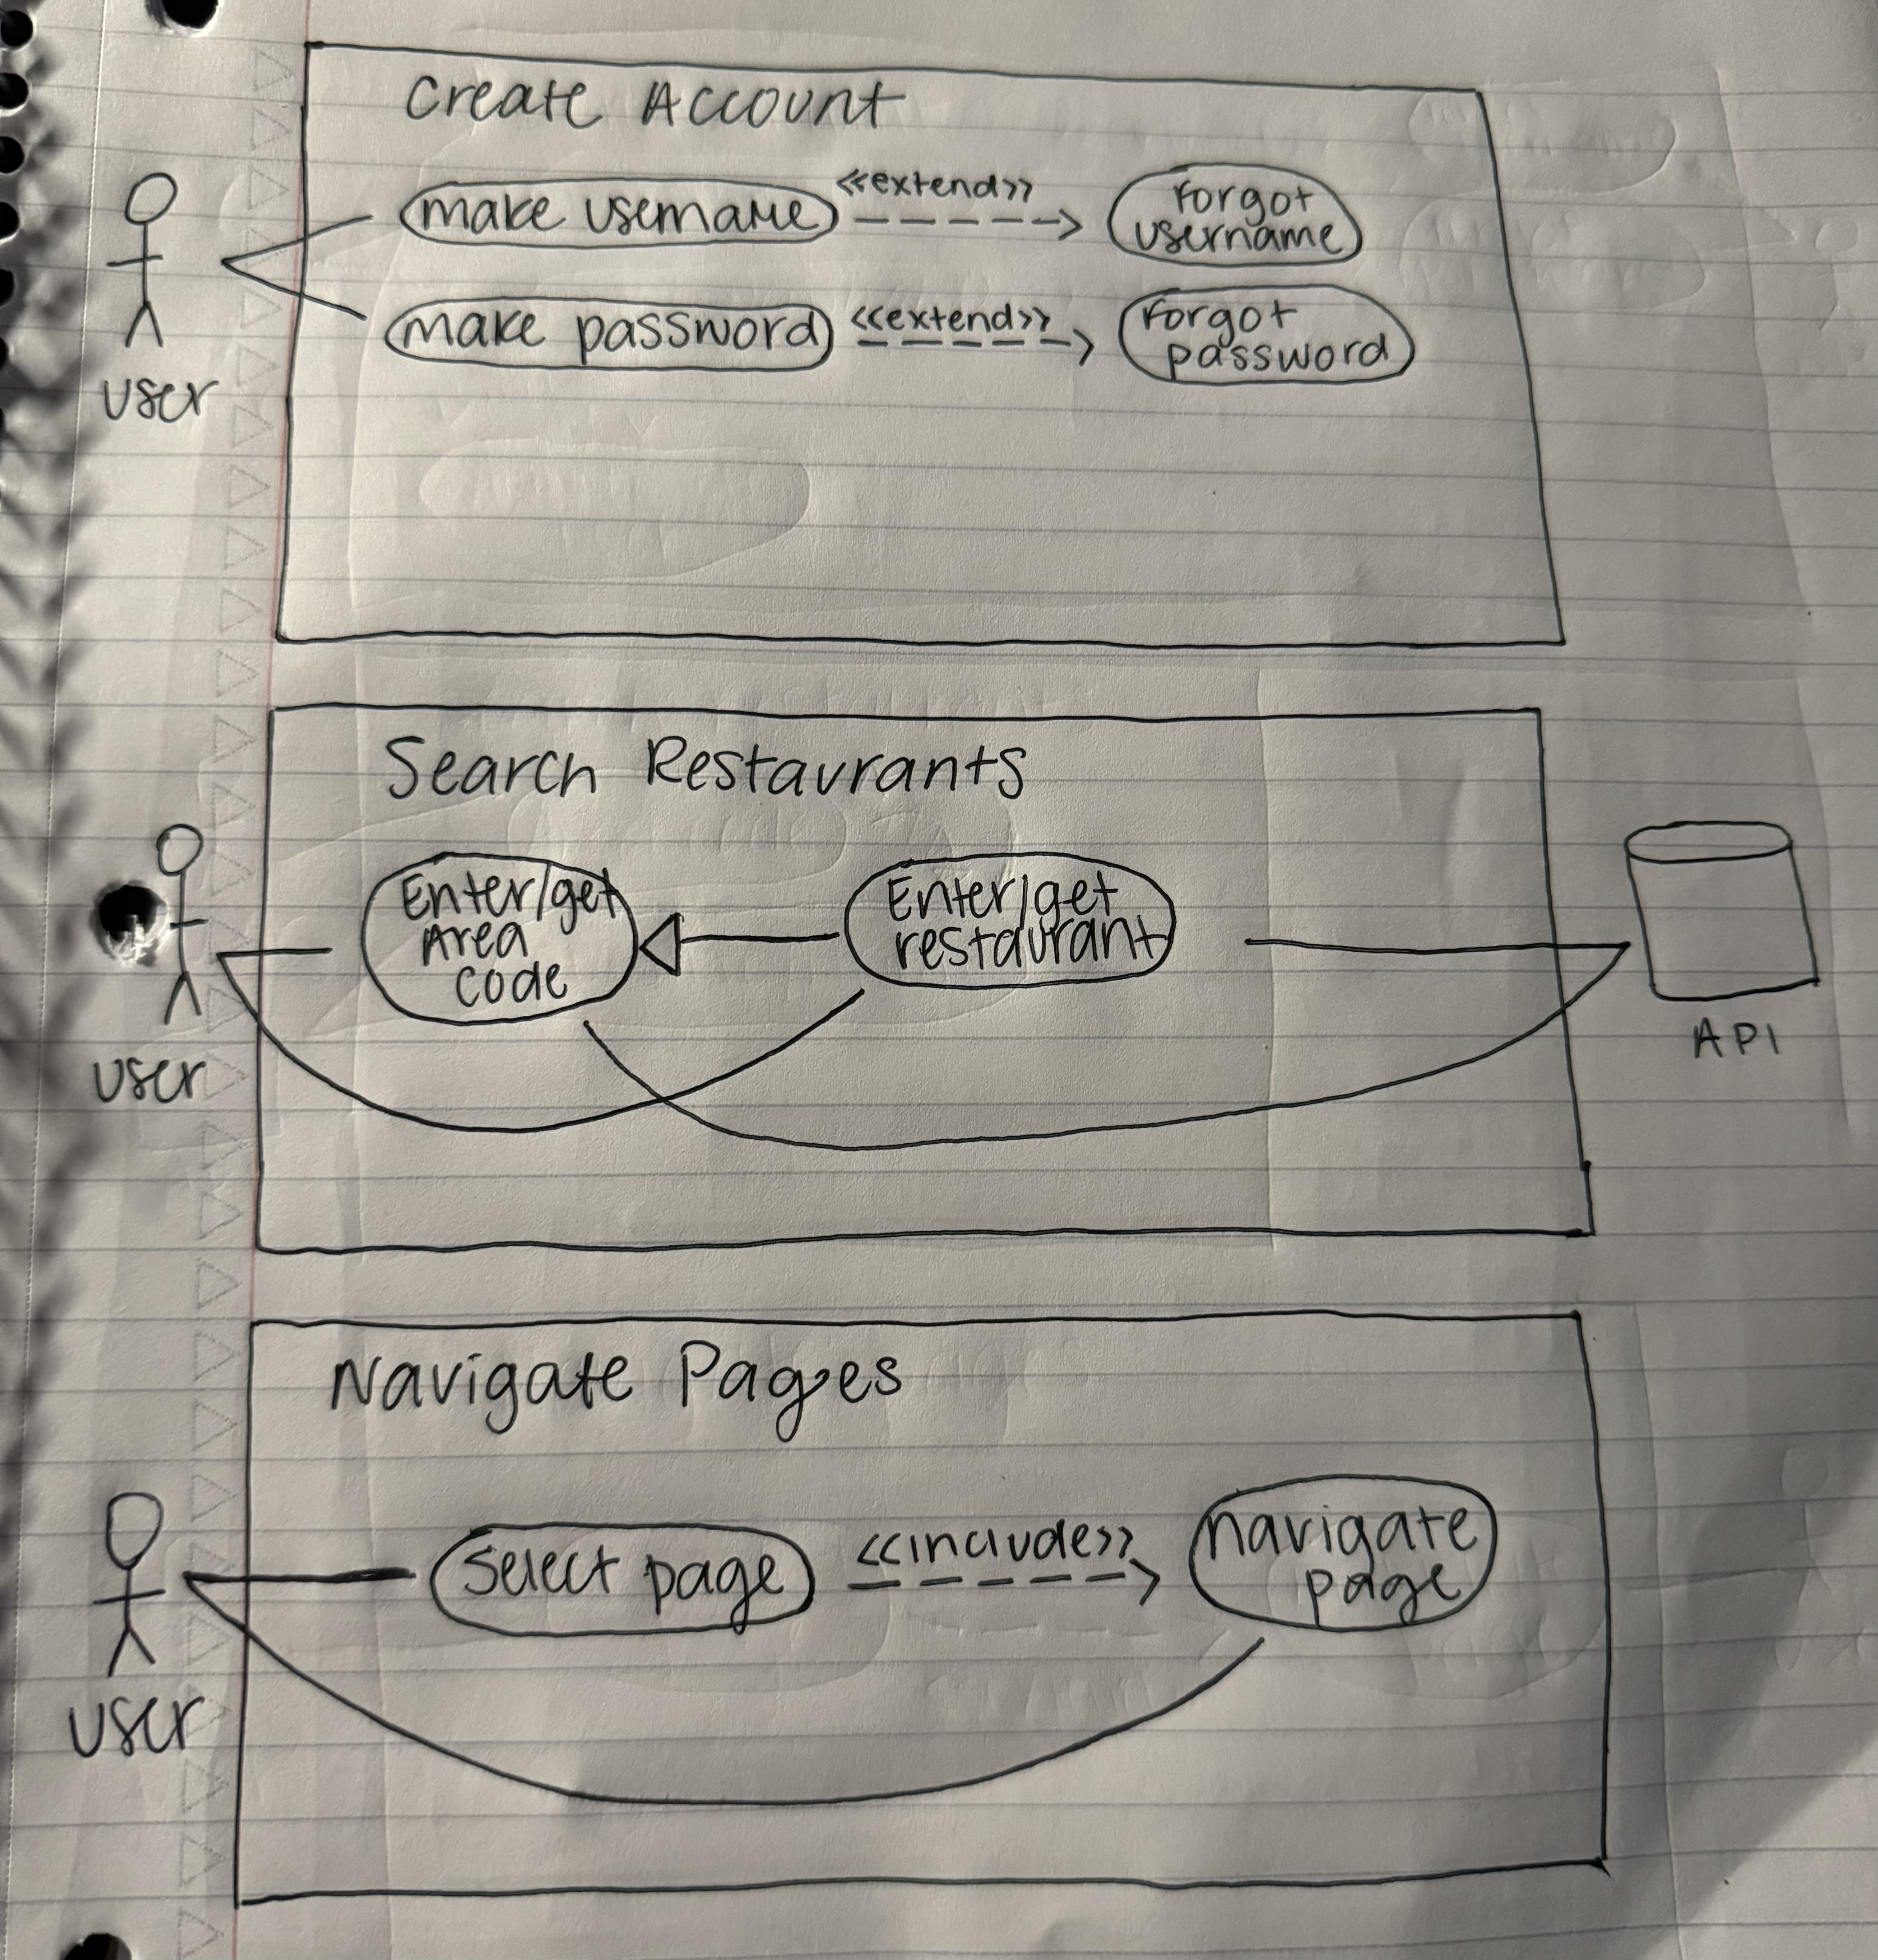

# Class Diagram and/or Sequence Diagrams (15 points)

Our project does not utilize classes, so we only have sequence diagrams.

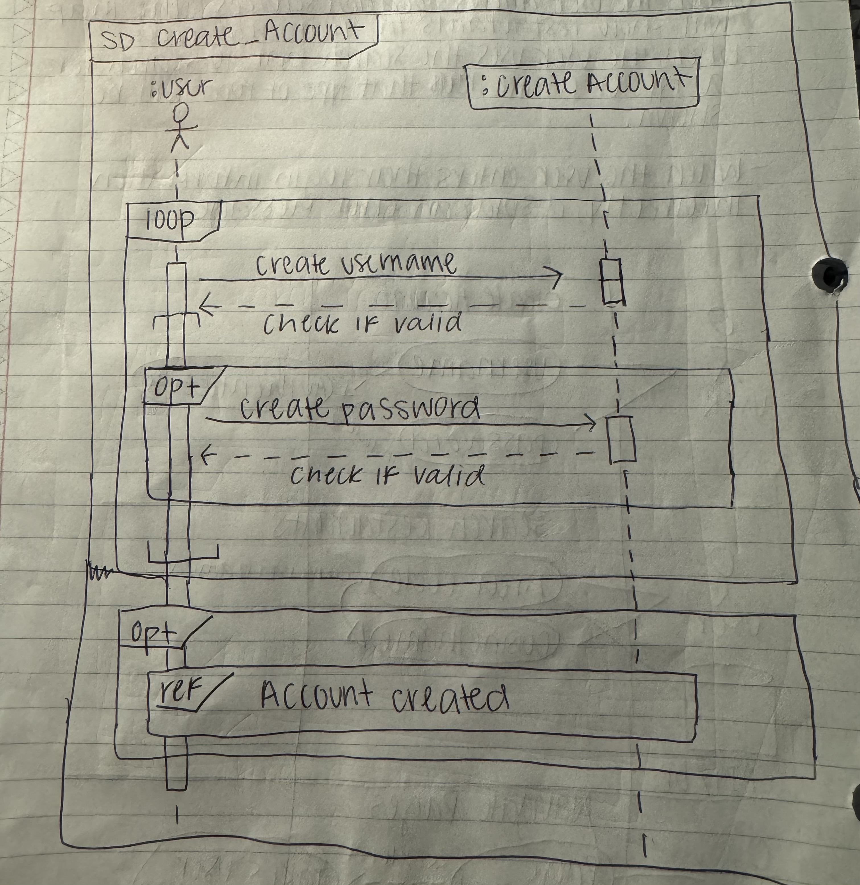

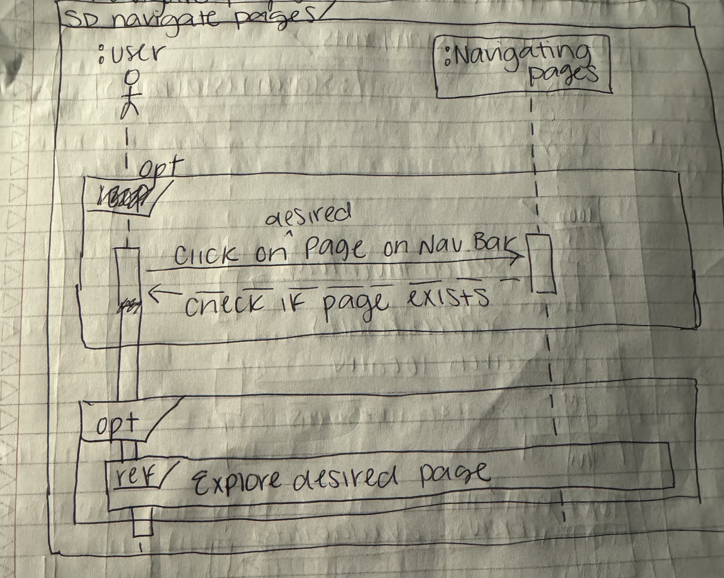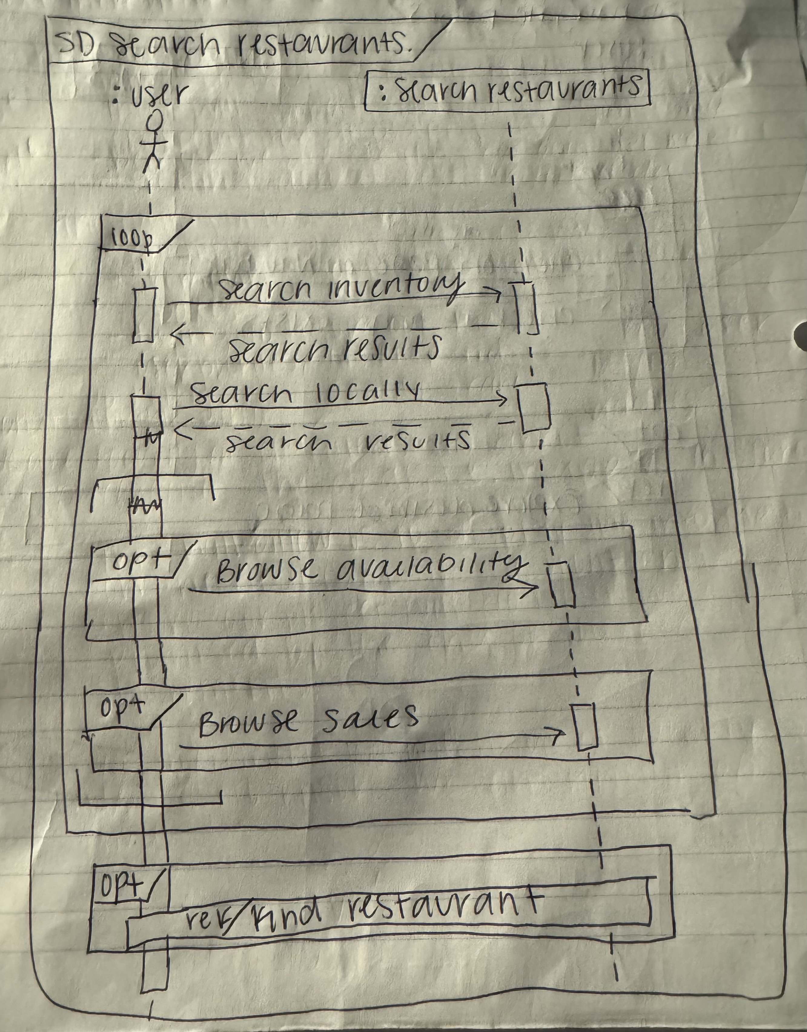

# Operating Environment (5 points)

The software is going to operate on the internet, as it is a webapp. This means it should be able to function on any type of web browser. The software should also be able to operate on any operating system, as the operating system does not usually alter the web browsers. The program should be able to function on any type of internet browser, and since any web browser usually coexists and works functionally with any application, it should work with any other application running on the computer. The hardware that can use the software is any hardware that has access to the internet and an internet browser and can search on that internet browser.

# Assumptions and Dependencies (5 points)

The web app could be affected by the time constraints, such as developing the API for the program. Dependencies of the software include, web browsers(chrome, edge, firefox, etc.), visual studio code to program the software, react to functionally use the javascript, html, and css to make the webapp operate, and postman to create the API for the webapp.